**Ideation Phase**

**Define the Problem Statements**

|  |  |
| --- | --- |
| Date | 31 January 2025 |
| Team ID | LTVIP2025TMID54894 |
| Project Name | DocSpot: Seamless Appointment Booking for Health |
| Maximum Marks | 2 Marks |

**Customer Problem Statement Template:**

**Who is experiencing the problem?**  
Patients seeking timely medical consultations, doctors looking to manage their appointments efficiently, and administrators overseeing medical operations in clinics and institutions.

**What is the problem they are facing?**  
Patients often struggle to find and connect with verified doctors quickly, especially in urgent situations. Booking appointments is cumbersome, lacks transparency, and there's no streamlined way to track consultations or follow-ups. On the other side, doctors find it challenging to manage patient interactions, maintain schedules, and present their professional credentials effectively. Administrators also lack a unified system to oversee doctor approvals, monitor appointments, and handle platform activity efficiently.

**Why is this a problem?**  
The lack of a centralized, digital solution leads to missed appointments, poor communication, low trust between patients and doctors, and inefficient workflows for healthcare institutions. This results in frustration, reduced healthcare access, and a poor experience for all stakeholders involved.

**What do they need?**  
Patients need a reliable, user-friendly platform to view verified doctors, check availability, and book, cancel, or reschedule appointments. Doctors need an efficient dashboard to manage their profiles, appointments, and patient interactions. Admins need tools to manage user approvals and system activity securely. The solution must be secure, intuitive, and scalable.

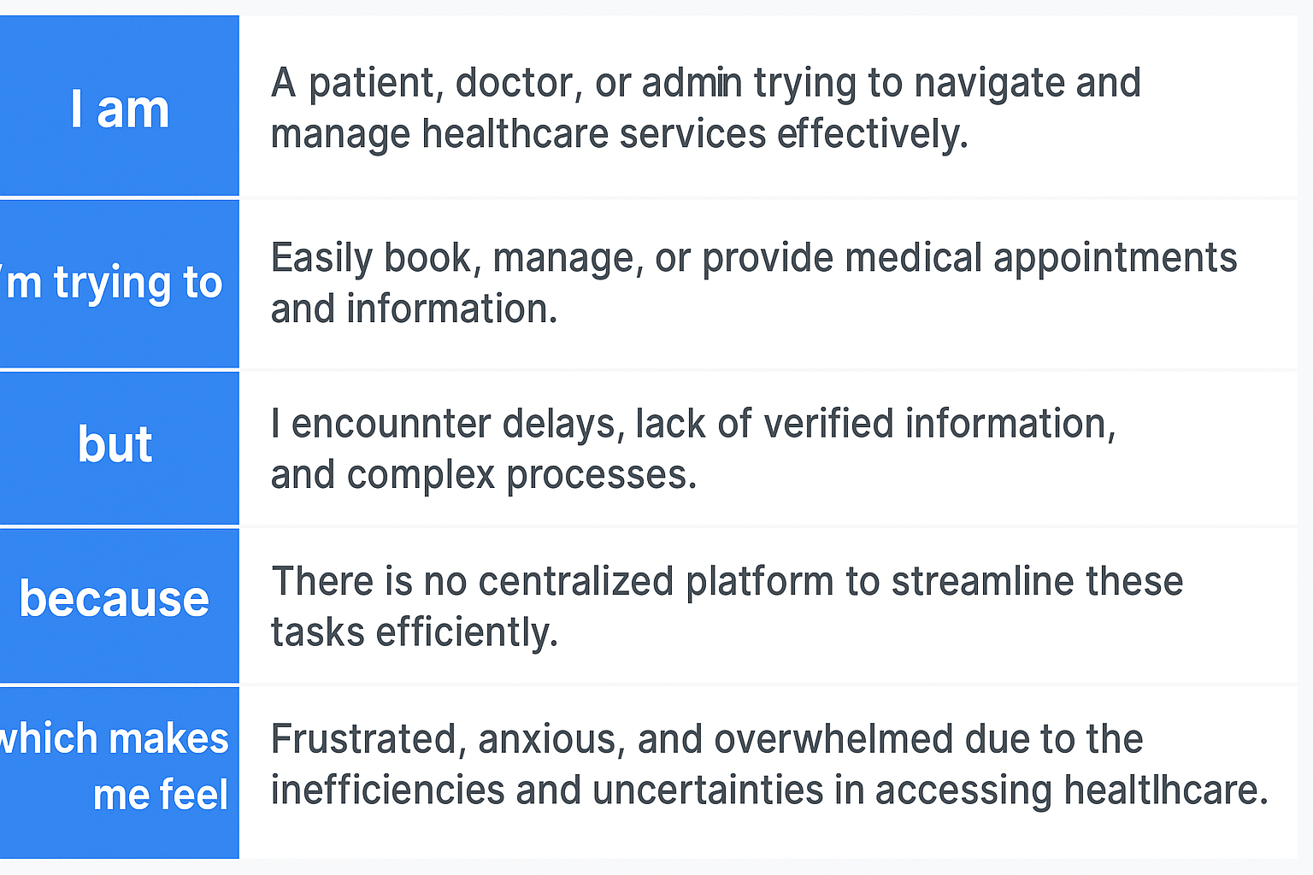

Reference: <https://miro.com/templates/customer-problem-statement/>

**Example:**

|  |  |  |  |  |  |
| --- | --- | --- | --- | --- | --- |
| **Problem Statement (PS)** | **I am (Customer)** | **I’m trying to** | **But** | **Because** | **Which makes me feel** |
| PS-1 | A college student with limited access to doctors | Book an appointment with a doctor easily online | There is no streamlined system for booking appointments in my campus | Manual processes or lack of centralized access delay appointments | Frustrated and neglected when my health concerns are not addressed on time |
| PS-2 | A newly registered doctor wanting to build credibility | Create and manage my professional profile for students to view | There's no platform to present my specialization or experience | Most platforms don’t allow easy profile visibility to patients | Underappreciated and disconnected from potential patients |